**Network Commands**

**Ping:**

The ping command is used to test the reachability of a network device or host, such as a server or website, on an IP network.

* ping www.google.com

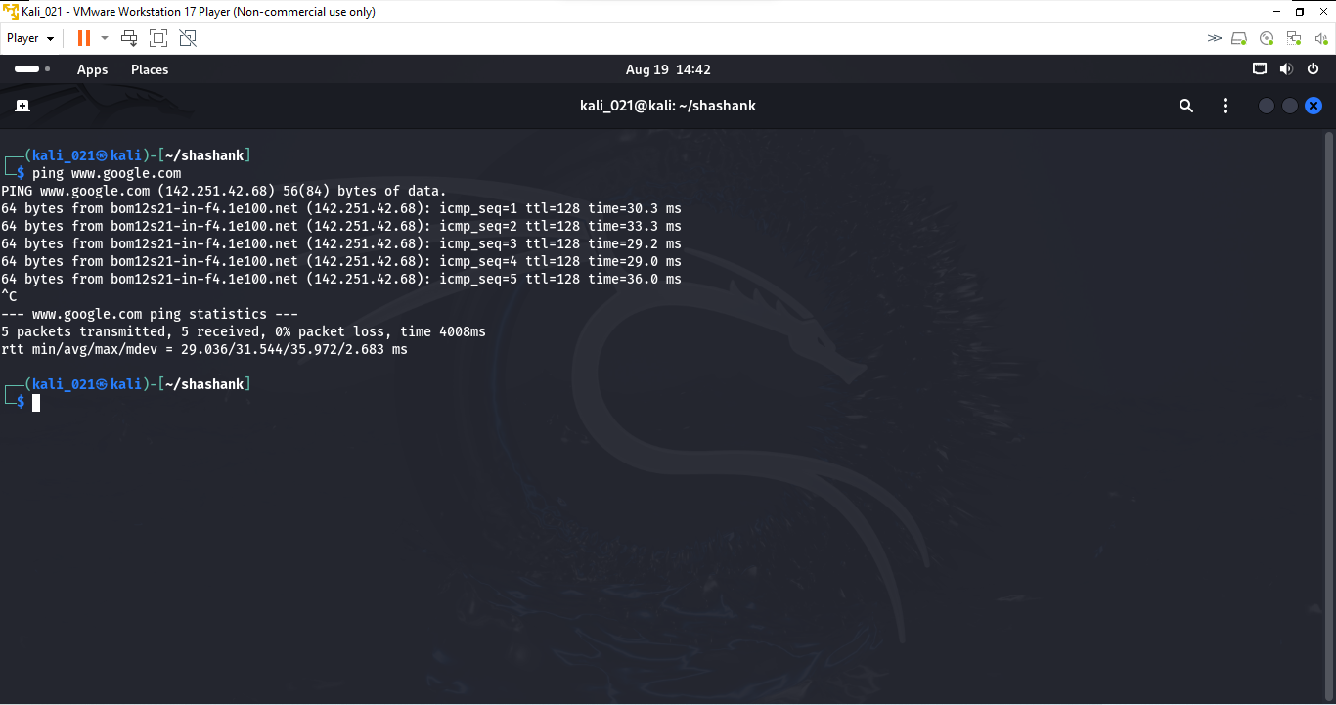

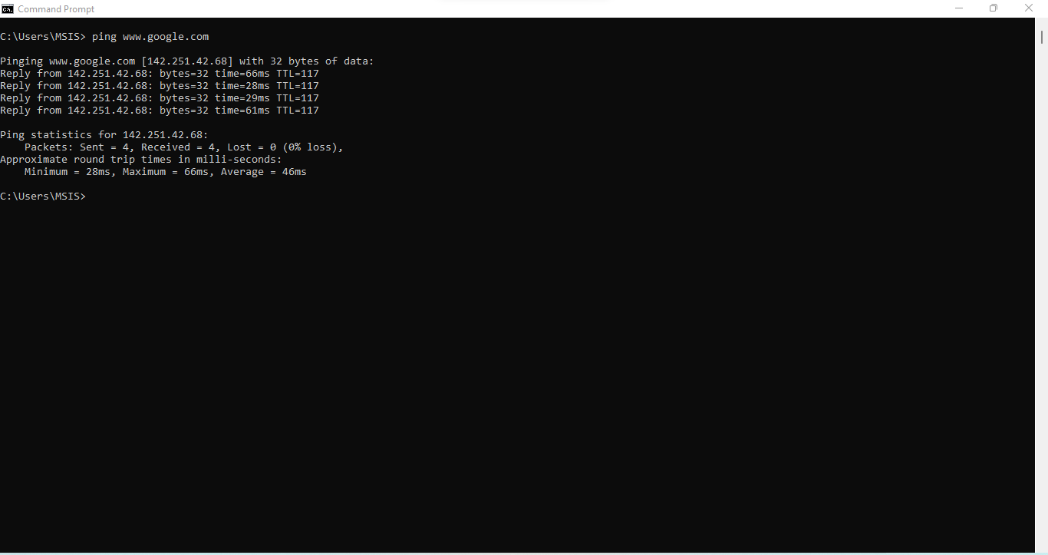

**Netstat:**

The netstat command generates displays that show network status and protocol statistics

* **netstat -a**: Shows all active connections and listening ports. This includes TCP and UDP connections.
* **netstat -n**: Command provides a numeric view of network connections and their details, bypassing the DNS resolution step.
* **netstat -b**: This command displays the executable (or binary) associated with each network connection.

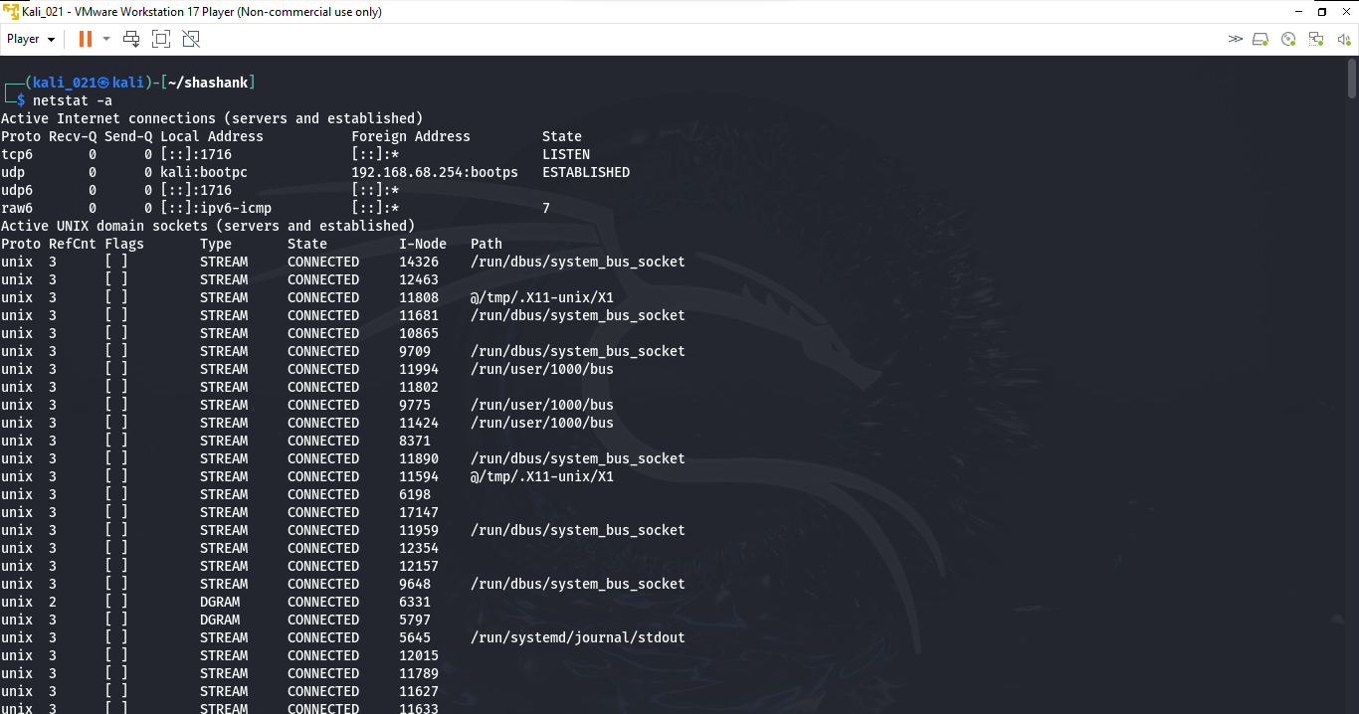

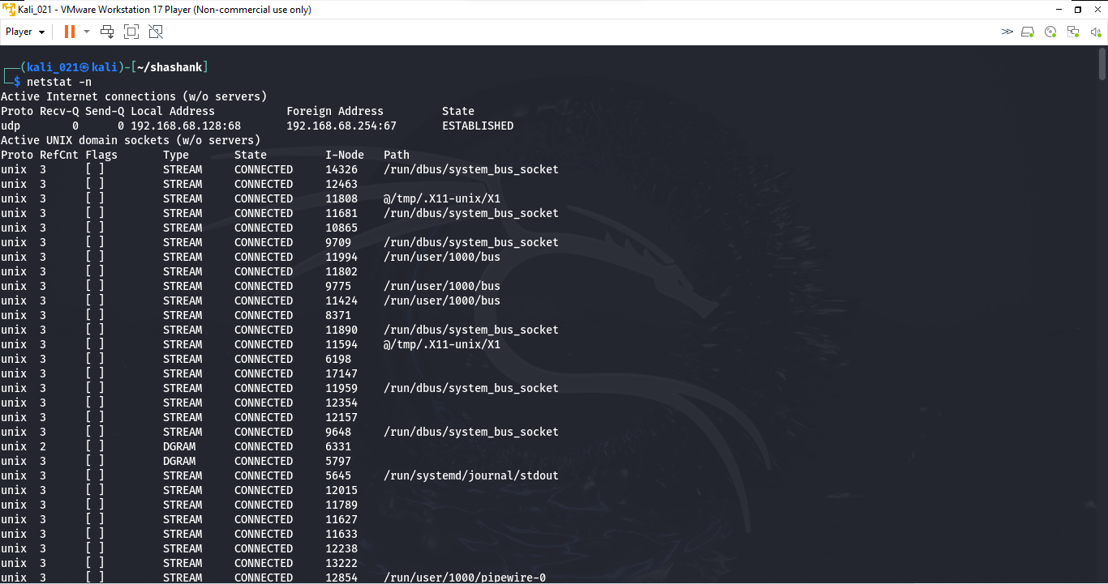

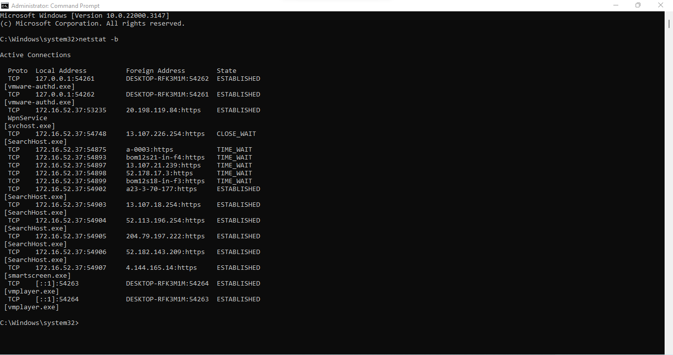

**Traceroute:**  Used to track in real-time the pathway taken by a packet on an IP network from source to destination, reporting the IP addresses of all the routers it pinged in between.

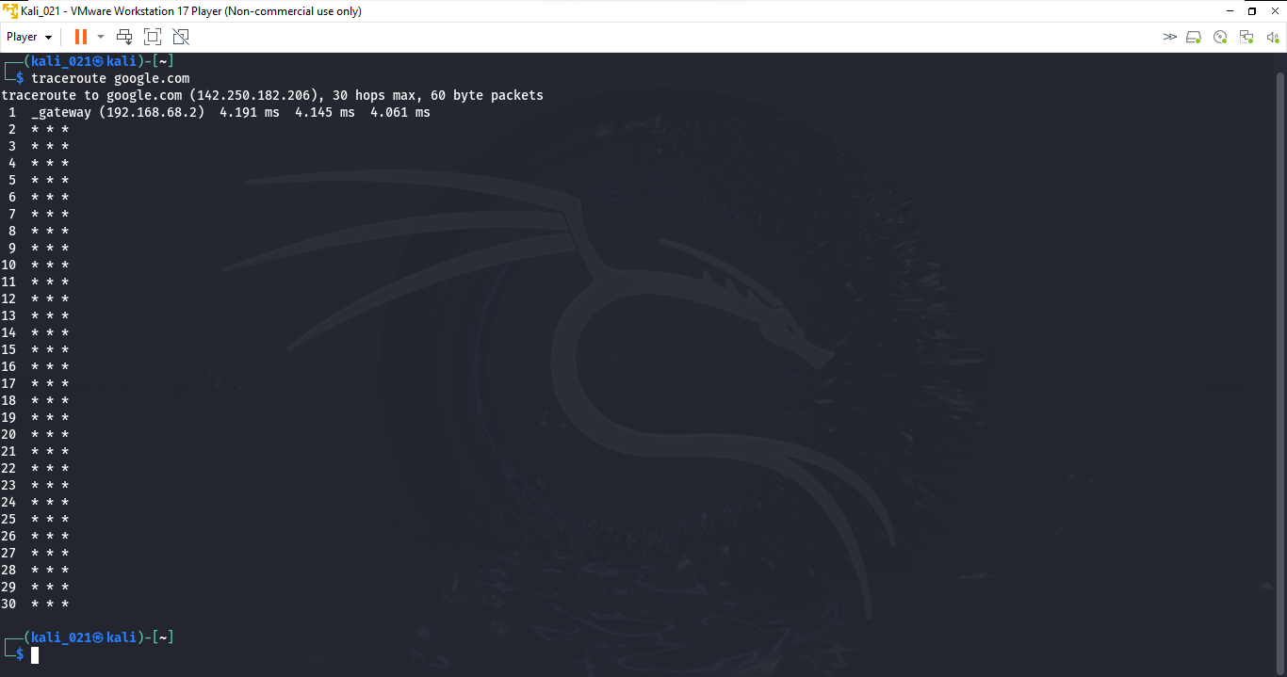

arp -a

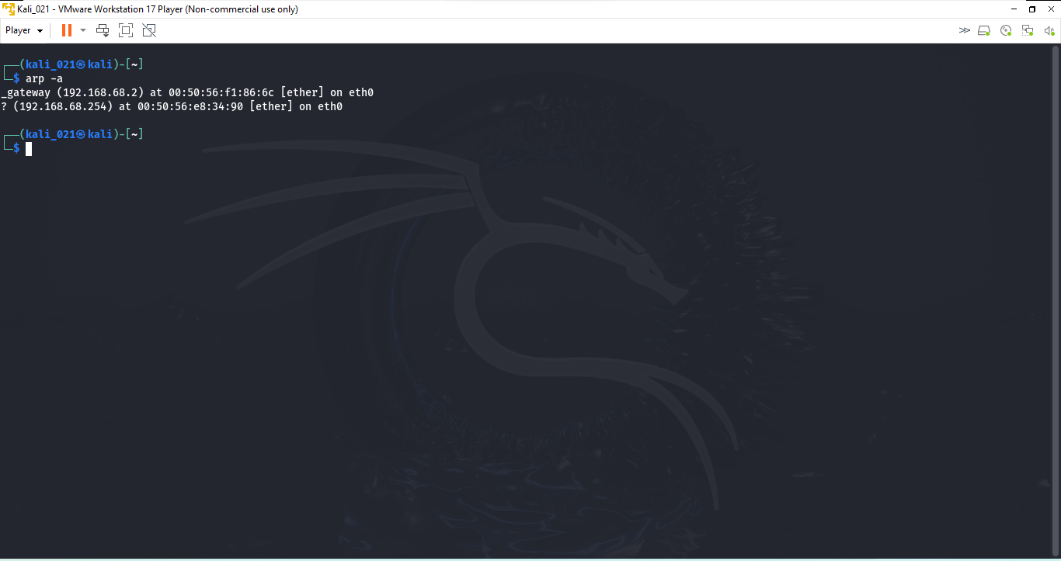

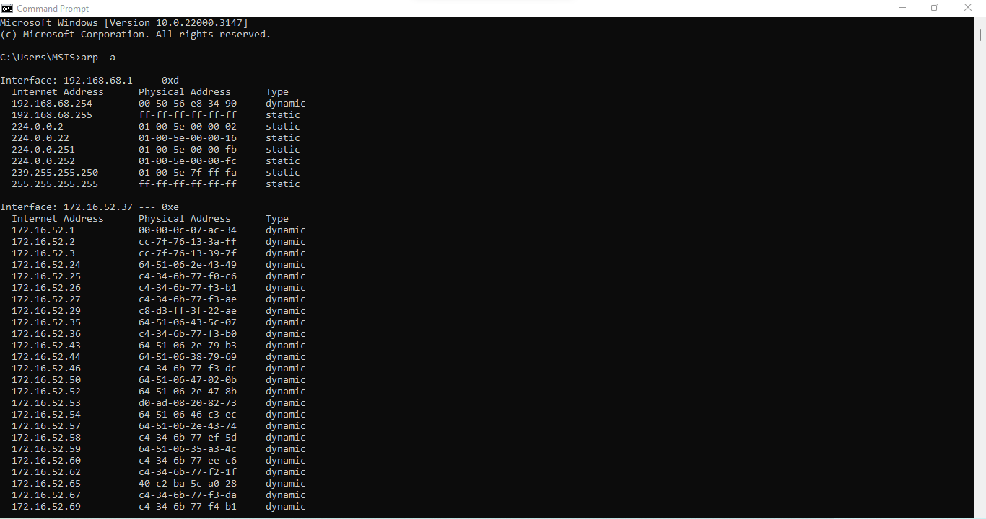

**Ifconfig**

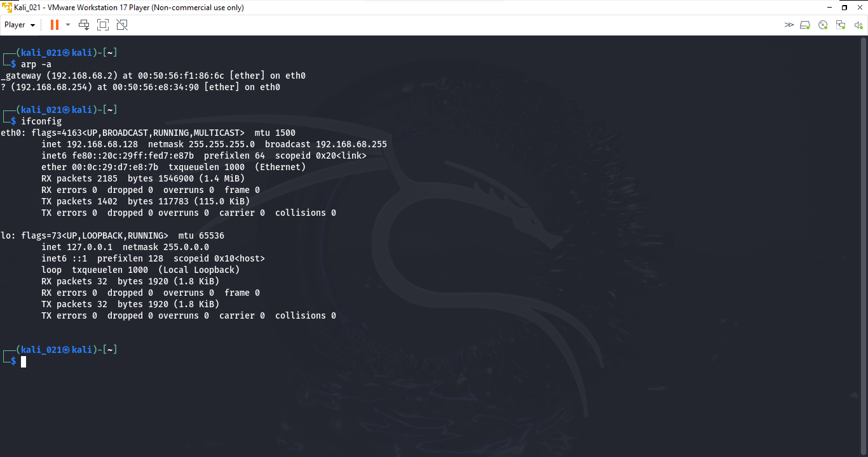

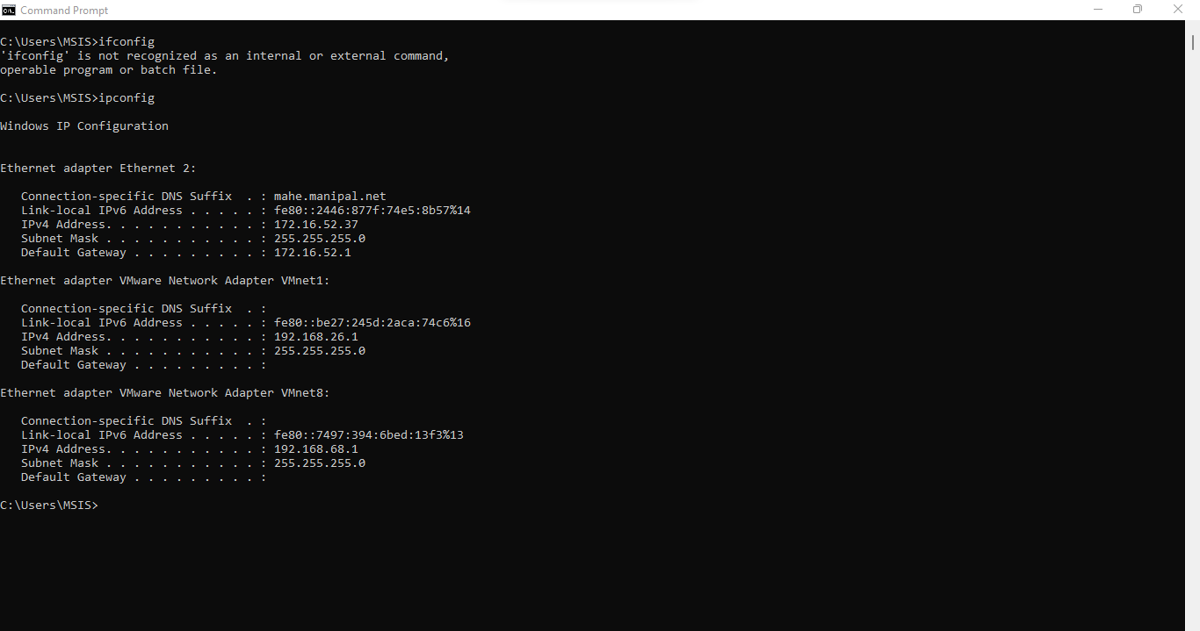

**iwconfig**

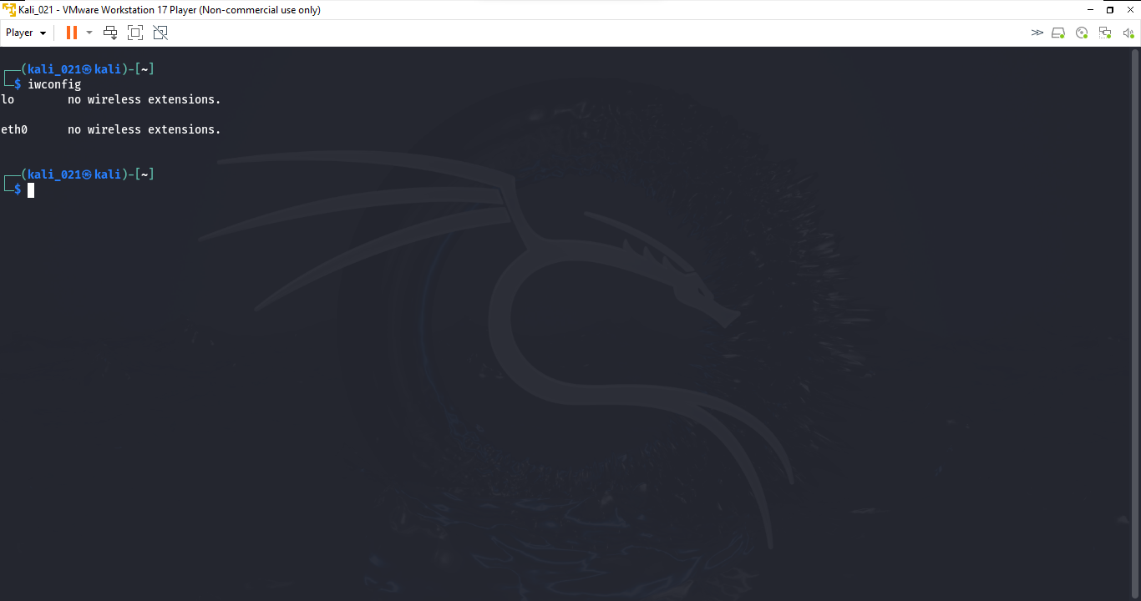

**Ip addr**

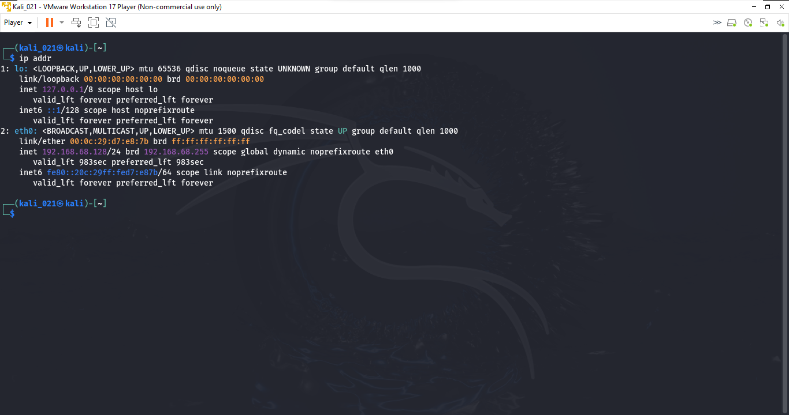

**nslookup**

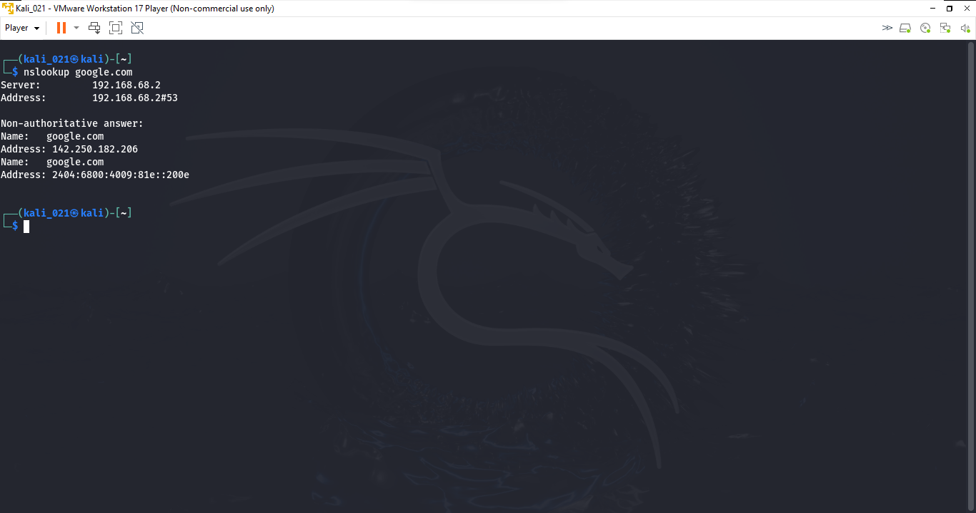

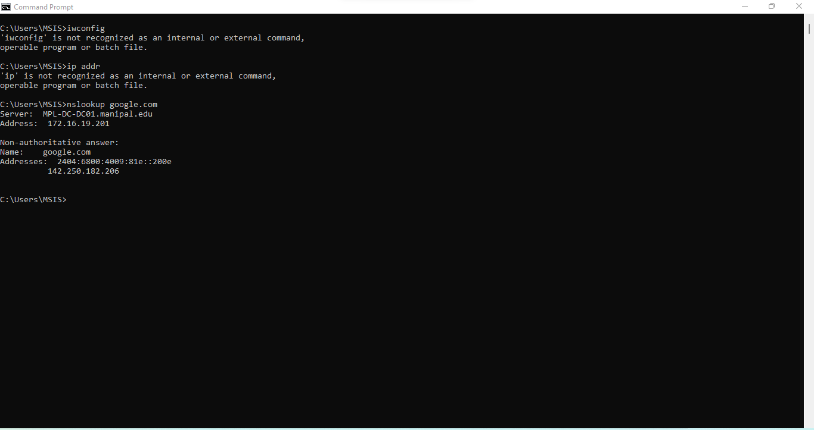

**Dig**

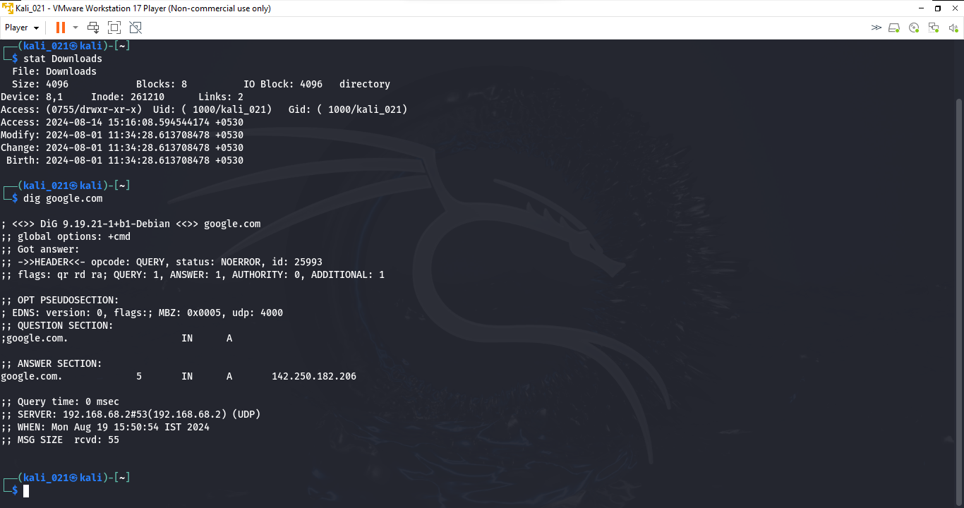

**Stat**



**Tcpdump**

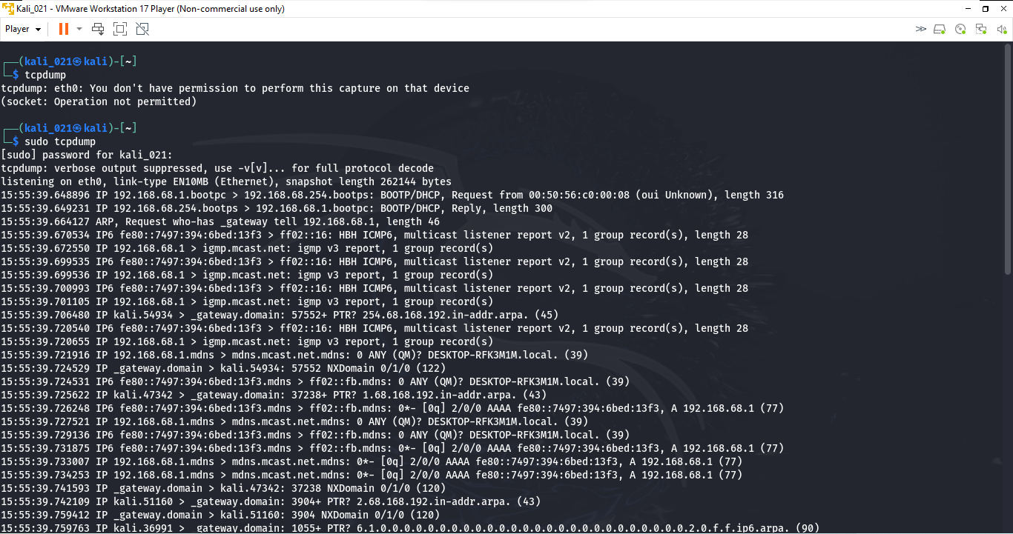

**Nmap**

